JDA Console

Thick client on JDA IKB Server
172.28.4.124
MSTSC 172.28.4.124
srd/IBM@1234

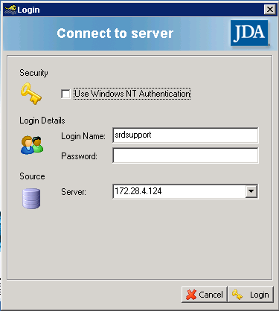 | srdsupport/JDA@1111  SuperUser  cespino/JDA@1234  SuperUser  emetz/JDA@1234  orojanava/JDA@1234  kchaney/JDA@1234  sa/IBM@1234  Admin

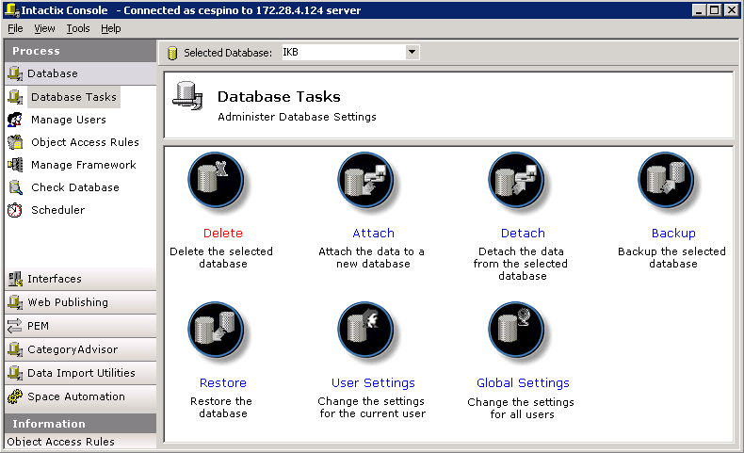

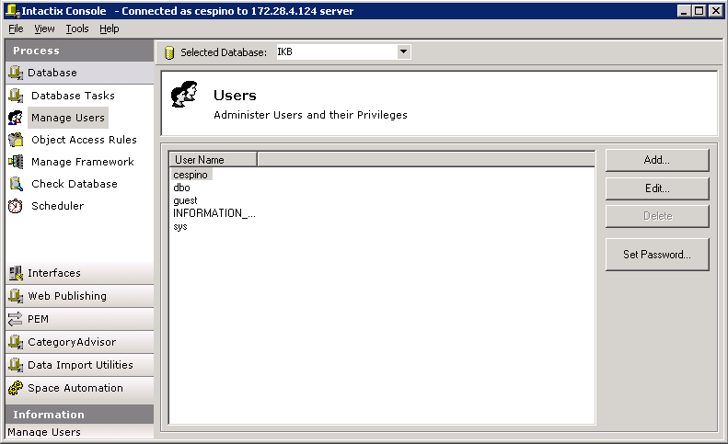

New user IDs will be created here

